SUBMITTED TO:
NIKE ADESANMI

BAN240ZAA
Date: 13TH August 2023
SUBMITTED BY GROUP 2:
ASHWEENI KARMACHARYA (139697221) BIKESH MAN CHIPALU (130000227) SAROJ DHAUBANJA (109824219)
Navigating Netflix's Growth Trajectory: Analyzing Subscription Trends and Strategies for Sustainable Success

From 2019 to 2023, the project delves into Netflix's subscriber trends and growth strategies using user behavior data and business analytics. It examines influencing factors and successful strategies to enhance subscription rates and overall revenue.
TABLE OF CONTENTS
EXECUTIVE SUMMARY: 2
INTRODUCTION: 4
LITERATURE REVIEW: 5
INDUSTRY OVERVIEW: 8
RESEARCH METHODOLOGY/DATA COLLECTION: 9
Research Questions 9
Data Collection and Sources 10
Data Preparation and Analysis 10
Tools Utilized 10
MAJOR FINDINGS, ANALYSIS, AND DISCUSSIONS 11
IMPLICATIONS FOR BUSINESS ANALYTICS MANAGERS 18
LIMITATIONS OF THE STUDY 19
REFERENCES 21

EXECUTIVE SUMMARY:
In the ever-evolving landscape of the information and cultural industry, we've chosen Netflix as our focal point due to its leadership in the field. Our objective revolves around understanding how Netflix's subscriber base changes over time and identifying effective strategies to increase subscriptions.
To accomplish this, we will gather data from trusted sources such as Kaggle, Netflix Pissed consumers, and Consumer Affairs. This data will encompass subscription trends, user feedback, usage statistics, and other pertinent metrics. Furthermore, we will scrutinize case studies and research articles to analyze both successful and unsuccessful strategies employed by Netflix and its competitors.
Through the application of statistical techniques, we will explore the connection between Netflix's subscriber base and various influencing factors such as revenue. This exploration will unveil patterns and trends in user behavior and preferences. By identifying the factors contributing to subscription decline, we can unearth potential opportunities and strategies for boosting subscriptions.
Subsequent sections of our report will present a literature review to assess the current landscape and an industry overview to provide contextual understanding. These sections will establish the foundation for our analysis and recommendations.
Our goal is to furnish both Netflix and the broader information and cultural industry with invaluable insights. By leveraging the potential of business analytics and big data, we aim to catalyze growth, enhancing personalized and immersive entertainment experiences for consumers.

INTRODUCTION:
The information and cultural industry stand as a dynamic sector with immense potential for innovation and transformative impact. Within this landscape, Netflix has emerged as a pioneering force, commanding a prominent position as a case study for our research endeavor. In an era of ever-evolving preferences and consumption patterns, our study centers on comprehending the evolution of Netflix's subscription base over a span marked from 2019 to 2023, and concurrently devising strategies to amplify subscription rates.
Problem Statement
In the midst of rapid industry transformations, the core challenge that this research addresses is the fluctuating subscription base and its resultant implications on revenue generation within Netflix and the larger entertainment industry. As consumption patterns shift and competition intensifies, sustaining and augmenting subscription rates become paramount. Our investigation, guided by data analysis, seeks to contribute to the improvement of Netflix's and other industry players' scenarios by identifying bottlenecks, enhancing revenue streams, and refining subscription strategies.
Objectives
The objectives of this study are multifold. Foremost, we aim to discern the nuanced shifts and trends within Netflix's subscription base from 2019 to 2023. Additionally, we strive to unravel the intricate relationship between revenue and subscribers, unearthing how these two critical variables interact and influence each other. By achieving these objectives, we intend to enhance the overarching landscape of the entertainment industry by promoting strategies that lead to heightened subscription rates and increased revenue streams.
Research Questions
The study revolves around two pivotal research questions:
- Has Netflix's subscription base experienced any changes over the years?
This question focuses on deciphering the dynamic shifts in the number of subscribers Netflix has garnered across the selected timeline. By analyzing subscription trends, we aim to pinpoint patterns that can guide strategic decisions.
- What is the correlation between revenue and subscribers?
This question delves into the intricate connection between revenue generation and the subscriber base. By exploring the correlation between these key variables, we aim to shed light on the financial implications of subscription fluctuations.

LITERATURE REVIEW:
Netflix placed the blame on several things, including growing competition and its choice to cancel all its Russian subscribers due to the conflict in Ukraine. The turning point in the ‘streaming wars' felt decisive to executives in the entertainment industry and viewers. They may finally see a chance to catch up to their great rival after years of trying. The media sector has been quickly restructuring itself to fully embrace streaming and compete with Netflix because it is concerned about falling broadcast television ratings and movie theatre ticket sales. Disney has made massive investments. Over the long term, the streaming business might still be enormous, but the coming years may be challenging, according to Rich Greenfield, an analyst with Light Shed Partners and a steadfast supporter of the industry. It appears to be much less profitable anyhow, and that is an issue for everyone, he added. Less profit for everyone when combined with fewer subscribers and more costs brought on by more intense competition to provide original content. The problems with Netflix put more pressure on Disney, which will release subscription data on May 11. The streaming industry will be plagued with distress signals if Disney's financial results fall short of projections. (Sperling)
While this was the case, new customers made up only 60% of cancellations in the period, down from 64% in the previous quarter. Additionally, in the first quarter, there were 3.6 million cancellations total, up from roughly 2.5 million in each of the five quarters before that. Antenna claims to obtain its data from a panel of 5 million Americans who voluntarily submit their streaming subscriptions in an anonymous manner. According to the data, Paramount+, Peacock, and Disney+ were the most widely used streaming services among new customers during the first four months of 2022. The fact that Paramount+ and Peacock are two of the most economical services is one of the causes. (Writer). Netflix's ingenious revenue-generating approach revolves around utilizing advanced technology. Their platform offers an extensive selection of movies and TV shows, conveniently sorted into categories under your personalized queue. For those who have moved beyond just watching blockbusters, Netflix's recommendations are surprisingly accurate and worth exploring. This strategic use of technology not only enhances user experience but also plays a significant role in Netflix's impressive financial performance. (Sampathkumar, 2023).
Several forecasts state that by the end of 2022, Netflix will have lost 2 million customers. Netflix is actively working on a new privacy policy, new ideas, and a few other strategies to address the issue. For instance, Netflix introduced a new subscription plan at the end of the year. The latter is a cheap plan that is supported by ads. (ARTASHYAN).
Creating an excellent customer experience with a focus on personalized merchandising and a straightforward, engaging viewing experience is one way to increase Netflix subscribers. providing many television programs and films, with growing investment in original material. experimenting to determine the best ratio between price and value. the release of a less expensive, ad-supported variation of its service. limiting access to the account. weekly releases as opposed to all at once for a series. (Hagiu). As for the subscriber base, as of the initial quarter of 2023, Netflix had about 232.5 million paid users globally. Compared to the prior quarter, there were 1.75 million more members at this time. (Writer).
The company's subscribers will continue to foot the cost if it continues to pour money into building its ever-expanding collection of premium Netflix Originals. It's interesting to note that Netflix is trialing a new cost option that includes a $2.99 per user fee to add people from outside your home. All of this has occurred since January 2022, when the most recent Netflix price increase took effect for new subscribers. It may not come as a surprise that this caused Netflix to report its first subscriber decline in more than ten years. And as we'll see below, this isn't the first time Netflix has raised its prices recently. HBO Max has recently seen a $1 per month price increase, so Netflix doesn't seem the only streaming site increasing costs. (Casey). Unlike most on-demand streaming services that offer uniform features, Netflix's subscription tiers determine simultaneous streams and streaming quality. The platform boasts a wide range of family-friendly and kid-specific content. Users can implement content restrictions using PIN codes for certain ratings or individual titles. Notably, Netflix permits the creation of up to four user profiles, aiding both content control and tailored viewing recommendations. In comparison, Disney+ supports seven profiles. (Minor, 2023).
By doing so, Netflix would be able to tap into a different source of growth: selling additional things to its current customer base. The benefit of the platform model is that it allows companies like Netflix to expand without having to acquire or create new content themselves. It only needs to draw in outside parties to create and market the material, after which it may receive (as is customary) a cut in the profits or a fee for handling the transaction. Additionally, third parties might try out novel formats of material, which might be very beneficial for Netflix's efforts to produce and acquire content. In this manner, Netflix would imitate Amazon. Before establishing an outlet where customers could make direct purchases from other sellers, the company first operated as a straight retailer of goods it purchased from vendors and marketed under its own name. Netflix may strive to develop into a similarly potent reseller-platform combination but with digital media rather than physical goods. (Hagiu).
Netflix presented itself as a site where you can view the series your peers are talking about by promoting certain shows. Netflix turns you into an "insider" who can watch ground-breaking programming. You can also participate in enjoyable discussions on what is happening to the show's characters. Many times, subscription businesses find it difficult to choose just one advantage. They sabotage their advertising by allowing benefits to slip in. (Skrob). Netflix has a huge collection of unique and high-quality TV shows, popular classics, family favourites, and its own trendy original content. You can also download shows to watch offline on your mobile devices, and there are no ads when streaming. But, the price has increased over time, and while a cheaper ad-based option is available, it's not enough to compete with rising streaming competitors. Despite that, Netflix is still highly recommended for on-demand streaming due to its awesome original shows and big library. (Minor, 2023).

INDUSTRY OVERVIEW:
There is a huge opportunity for companies to grow in the digital entertainment industry. Streaming content online has become a hot topic in the entertainment industry. During the pandemic in 2020, people were stranded inside their houses which led to an increase in the average time spent consuming digital content. Companies like Netflix added a party feature contemporaneous with the pandemic where friends and families could virtually watch simultaneously from different locations. (Anonymous)
One of the big challenges faced is the increased competition. Knowing customer preferences has become a key to acquiring and retaining customers. Failing to do so might cost the risk of losing customers to competitors who provide better service. Customer preferences can be better studied and understood with the help of data science and analytics. (Still).
One advantage that the digital entertainment industry has is they have their customer’s data. The users leave digital footprints based on their activities. It can be used in various ways to profit from it. Statistical models are used to identify the patterns hidden in the data. With the help of these insights, Netflix provides recommendations to users based on their time spent, preferred genre, completion rate, etc. The use of Business analytics will not only help increase the growth rate but also develop a competitive advantage to outperform the competitors. (Dixon)
Technological innovation has now become a crucial part of the industry. Companies in the industry need to keep up with the transformation in the digital platform (Arockiasamy). The ones that can integrate the transformation well would be able to grab the market share. Blockbuster went bankrupt just because its competitor Netflix was providing better and more convenient service to its customers on an online platform. (McKinnon)
Therefore, the biggest competitive advantage would be to be able to smoothly transition to digital transformation. The most recent trend that is prevalent in the industry is the rise in popularity of Augmented and Virtual Reality. Creating content in Augmented Reality and Virtual Reality is boosting the engagement of the viewers and the content creators. (16 Trends in The Media And Entertainment Industry To Watch).

RESEARCH METHODOLOGY/DATA COLLECTION:

Our research methodology is designed to comprehensively address the research questions by employing a pragmatic approach that amalgamates elements of both positivist and advocacy paradigms. This approach enables us to understand the correlation between Netflix's revenue and its subscriber base evolution over time.

Research Questions
The primary research questions guiding our investigation are as follows:

- Changes in Netflix Subscription Base Over Time
We inquire into whether Netflix's subscription base has undergone any significant changes across different years.
- Correlation Between Revenue and Subscribers
We examine the potential correlation between Netflix's revenue and the number of subscribers, aiming to discern any patterns or relationships between these variables.

Data Collection and Sources
Our data collection process was meticulous, encompassing both quantitative and qualitative dimensions.

About Dataset

The "Netflix OTT Revenue and Number of Paid Subscribers" dataset contains information about Netflix's financial performance and subscriber base across various regions. It includes details such as global revenue, revenue from specific regions (UCAN, EMEA, APAC, LATM), and the average revenue per user (ARPU). The dataset's time frame follows Netflix's financial year, running from January 1st to December 31st, with quarterly granularity. All revenue figures are in US Dollars. This dataset offers insights into Netflix's revenue distribution, subscriber counts, and user engagement patterns on a global and regional scale.

To ensure robust analysis, we leveraged various sources:

- Quantitative Analysis Data: For quantitative analysis, we acquired the Netflix Over-The-Top (OTT) Revenue and Subscribers dataset from Kaggle. This dataset provides a wealth of information about revenue and subscriber figures over time. (MAURYA, 2023)

- Qualitative Analysis Data: For qualitative insights, we gathered data from platforms like Consumer Affairs and Pissed Consumers, which host consumer feedback and reviews. This qualitative data supplements our quantitative findings by offering valuable contextual information and sentiment analysis. (Netflix Reviews, 2023) (Trout, 2023)

Data Preparation and Analysis
Our approach involved a series of steps to ensure the reliability of our results:
- Data Cleaning and Filtering:
We meticulously cleaned and filtered the datasets to eliminate noise, inconsistencies, and missing values, thereby enhancing the quality of our analysis.

- Exploratory Data Analysis (EDA):
EDA allowed us to uncover initial trends and patterns within the data, providing a foundation for deeper analysis.

- Data Visualizations:
Utilizing tools such as Tableau, Excel, and Python libraries, we created data visualizations to present key findings succinctly and intuitively.

- Sentiment Analysis:
By employing sentiment analysis techniques like Lexicon based Analysis and Word cloud Analysis, we extracted sentiments from consumer feedback, shedding light on consumer perceptions and sentiments related to Netflix's service.

Tools Utilized
Throughout the research project, we employed a range of tools to ensure comprehensive analysis:
- Excel: Utilized for data cleaning, filtering, and preliminary analysis.
- SAS: Employed for statistical analysis and validation of quantitative findings.
- Tableau: Employed for generating interactive and insightful data visualizations.
- Python Libraries: Utilized for sentiment analysis and supplementary quantitative analysis.

In adopting this research methodology, we strived to attain a well-rounded understanding of the research questions, blending quantitative and qualitative approaches to provide a comprehensive view of the dynamics between Netflix's revenue, subscribers, and their evolving sentiments.

MAJOR FINDINGS, ANALYSIS, AND DISCUSSIONS

To determine the dynamics between Netflix's subscription base and revenue, we used both quantitative analysis and qualitative analysis approaches leading to significant findings and meaningful discussions.

Quantitative data analysis and findings

Trends in Subscriptions and Revenue
When we studied historical trends, a clear pattern emerged. Subscriptions experienced a notable surge from the first to the second quarter of 2022. In contrast, there was a decline in subscriptions towards the end of 2021 and the beginning of 2022. This pattern hinted at a possible correlation between subscription numbers and revenue fluctuations.

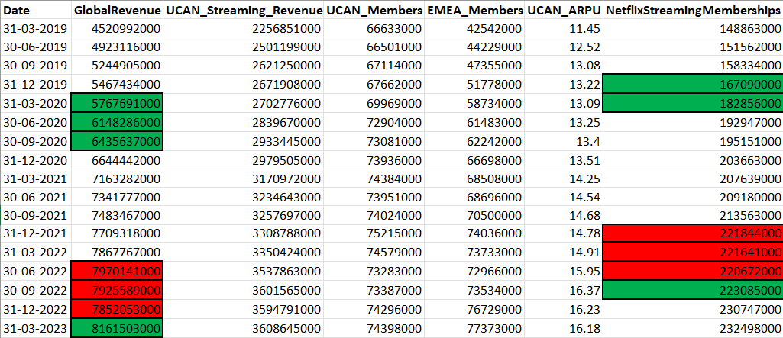
Figure 1: Analyzing trend at different time intervals.

Visual Confirmation with Tableau
Using Tableau, we transformed data into visual representations. The result aligned with our initial observations. Subscription rates and revenue trajectories closely mirrored each other, strengthening the idea that these variables were intertwined.
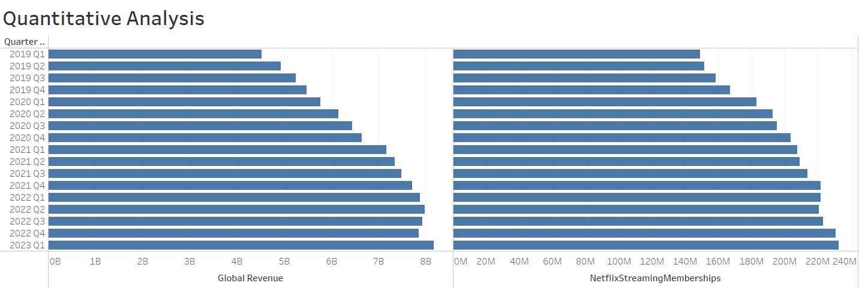
Figure 2: Visualization of Revenue and Subscription Base

Strong Positive Correlation via SAS Analysis
Delving deeper with SAS, we found a remarkable discovery: a correlation coefficient of 0.98551 between subscriptions and revenue. This high positive correlation pointed to a robust relationship between these factors. Our scatter plot analysis further emphasized this connection, solidifying our analysis.
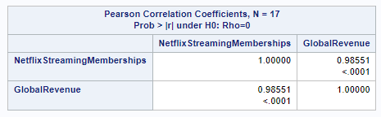
Figure 3: Correlation between revenue and subscription
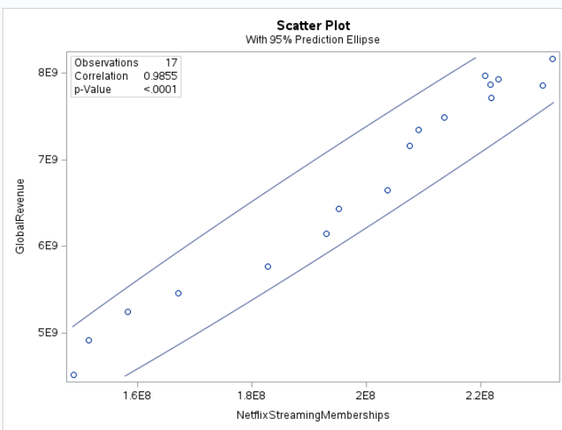
Figure 4: Using scatterplot to visualize the correlation.
Our quantitative analysis lays the groundwork for our research. Next, we explore consumer feedback from a human perspective on these trends by delving into qualitative insights from consumer feedback and reviews, enriching our understanding.

For the detailed code in SAS, refer to Appendix 1.

Qualitative data analysis and findings
Methods:
In our qualitative data analysis, we focused on reviews extracted from two specific websites that hosted discussions about the platform. The reviews were meticulously extracted and cleansed using MS Excel. The dataset covered reviews from October 1, 2021, to March 31, 2022, providing a focused timeframe for analysis.
Data Cleansing and Extraction:
Using MS Excel, we carefully extracted and cleaned the reviews from the selected websites. This step ensured that the data used for analysis was accurate and relevant.
Natural Language Processing Techniques:
Employing Natural Language Processing (NLP) techniques, we delved into the reviews to gain deeper insights. Two key concepts were employed: Lexicon-Based Analysis and tokenization of sentences into words.
Wordcloud Generation:
One outcome of our analysis was the creation of a Wordcloud. This visualization technique highlighted frequently mentioned words, with larger fonts indicating higher frequency. Notable terms such as "Charged," "service," "card," "account," "payment," "cancel," and "money" emerged.
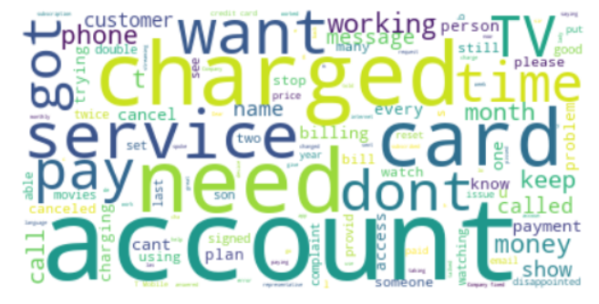
Figure 5: Determining the most repeated words using Word cloud.
For detailed code in python, refer to Appendix 2
Identifying Key Themes:
We further narrowed our focus to reviews containing the terms 'Charged' and 'account'. This allowed us to delve deeper into customer experiences. Through a careful analysis of a random 30% sample of these filtered reviews, we identified recurring themes related to payment issues.

Sentiment Analysis:
Using Lexicon-Based analysis, we categorized reviews based on sentiment—positive, negative, or neutral. The compound score provided insights into the intensity of sentiment. Our analysis revealed a particularly negative sentiment score of -0.995, indicating widespread dissatisfaction among subscribers.
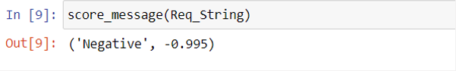
Figure 6: Final Score after Lexicon based analysis.

For detailed code, refer to Appendix 3

Theme Insights:
Our analysis of reviews highlighted a consistent trend related to payment system glitches, overcharging instances, and charges applied despite account cancellations. These reviews underscored customer discontentment with billing, account management, and financial aspects.
Key Takeaways:
The findings emphasize the critical nature of addressing payment-related concerns to enhance customer satisfaction. The analysis provides valuable patterns and insights into prevalent sentiments and recurring themes, contributing to a comprehensive understanding of the platform's user experiences within the specified time frame.

CONCLUSIONS AND RECOMMENDATIONS
In summary, our comprehensive analysis focused on addressing key research questions related to Netflix's declining revenue. The combined approach of quantitative and qualitative methods provided a holistic understanding of underlying patterns. Through quantitative analysis, we identified significant trends in subscriber behavior and revenue, establishing a quantitative foundation. Qualitative exploration revealed a crucial factor: a steep drop in subscribers. This decline was attributed to challenges stemming from deficient customer service and system glitches, particularly issues like overcharging and incorrect charges. These findings underscore the critical importance of enhancing customer service and addressing system issues to guide Netflix towards sustained growth and success.
Recommendations:
- Enhance Billing Transparency and Accuracy:
Regular audits of the billing system should be implemented to ensure precise charges, minimize overcharging, and enhance billing transparency. This can improve subscriber trust and satisfaction.
- Invest in Customer Service Enhancement:
Allocating resources to enhance customer support initiatives is essential. Prompt and effective assistance for subscribers facing issues can lead to increased customer satisfaction and loyalty.
- Emphasize Service Value and Communication:
Clear communication about service benefits and tips on maximizing subscriptions can significantly contribute to customer retention. Informing subscribers about the value they gain from their subscriptions can enhance overall satisfaction.

Reflection and Future Studies:

Based on our experience, future studies could explore the relationship between content variety and subscriber retention. Investigating how diverse content impacts customer loyalty could offer valuable insights. Additionally, examining the impact of personalized recommendations on subscription growth could provide a deeper understanding. Lastly, expanding the dataset to cover a longer timeframe might capture more comprehensive trends and changes in subscriber behavior over time, leading to more accurate conclusions.

IMPLICATIONS FOR BUSINESS ANALYTICS MANAGERS
Based on research finding that we have done, Business Analytics Managers must implicate:
1. Revenue-Subscriber Correlation: The connection between revenue and subscribers shows that changes in subscribers directly affect how much money Netflix makes. Business managers need to keep an eye on how many people are subscribing to predict how much money they'll earn and make smart decisions. They should find schemes to get more people to subscribe, like making the price lower or offering special deals to attract customers: new members will get a second-month free subscription.
2. Visualization's Value: Using Tableau to make pictures helps show the ups and downs in the data. Managers should know that pictures are important to explain things to others and help make better choices. It's important for managers who analyze business data to keep getting better. Managers who work with business data should use what they learn to make better decisions and get good results.
3. External Factors: Seeing how COVID-19 affected more people signing up for Netflix shows how things outside the company can make a difference. Managers need to think about how things from outside can change how well the company does. Managers can use what they learn from data to change how the company works when things outside change.
4. Subscriber Fluctuations: When the number of subscribers and money earned goes down, it shows that keeping customers can be tricky. Managers should work ahead to handle these ups and downs by understanding what customers do and finding ways to keep them interested.
5. Data Relevance: Even though the dataset isn't very big, the useful information it provides is more important than having lots of data. Managers should focus on picking good data that fits what they're trying to find out, rather than just having a lot of data.
6. Niche Marketing Strategy: As a Business Analytics Manager, a strategic approach would be to apply the Niche Marketing Strategy to countries where Netflix hasn't been introduced yet. Just like how Netflix streams content tailored to specific countries' preferences, such as having different shows for the UK and Australia, this strategy involves using analytical tools to understand the preferred content in a new country. By analyzing local preferences, you can introduce Netflix with content that resonates well with that specific audience. This adaptation ensures that the content aligns with local tastes, making it more appealing and increasing the chances of successful market entry. This way, we also make sure Netflix has the right shows for each place, making more people want to use it.

LIMITATIONS OF THE STUDY

- Data accessibility and availability:
While conducting the research, it was difficult for us to find good data. And, also found that many people have done the analysis based on the limited dataset. The analysis that we have done and the finding that we have come across, even though is a comprehensive one and gives a lot of proof about the trend, might not be fully dependable entirely, reliable and could benefit from further examination.
- Contextual information is limited:
Apart from data constraints, we faced limitations in accessing detailed information. While trying to pinpoint the issues accurately, we encountered only concise information. This highlighted the potential for improved results and recommendations with more extensive data.
Apart from the limitation that we have faced while conducting this research, this research has helped us to boost our thinking and has provided a broader picture of how the research analysis can be operated to figure out the right decision. This research has also taught us how companies can use various data analysis tools to develop a stronger bond with customers through their reviews and feedback. However, all in all, it was a very good experience and learning opportunity for us.

REFERENCES
- "16 Trends In The Media And Entertainment Industry To Watch." n.d.
<https://opengeekslab.com/blog/trends-in-media-and-entertainment-industry/
#2_Augmented_Reality_and_Virtual_Reality_as_the_Top_Digital_Media_Industry_Trends>.
- Anonymous. "The opportunities and challenges faced by Netflix in a digital world." n.d. <https://medium.com/digital-society/the-opportunities-and-challenges-faced-by-netflix-in-adigital-world-cd372d3af98c>.
- Arockiasamy, Satya. "3 ways to beat the competition and stay ahead in the Media and Entertainment industry." 2021. <https://blog.trigent.com/stay-ahead-in-the-media-andentertainment-industry/>.
- ARTASHYAN, ARGAM. "EVERYTHING YOU SHOULD KNOW ABOUT NETFLIX SUBSCRIPTION PLANS AND THE CURRENT SITUATION." 2022.
<https://www.gizchina.com/2022/05/17/everything-you-should-know-about-netflix-subscriptionplans-and-the-current-situation/>.
- Casey, Henry T. "Netflix price in 2023: How much you pay and what you get." 2023.
<https://www.tomsguide.com/news/netflix-pricing>.
- Dixon, Michael. "How Netflix used big data and analytics to generate billions." 2019. <https://seleritysas.com/blog/2019/04/05/how-netflix-used-big-data-and-analytics-to-generatebillions/>.
- Hagiu, Andrei. "The Best Way for Netflix to Keep Growing." 2018.
<https://hbr.org/2018/08/the-best-way-for-netflix-to-keep-growing>.
- McKinnon, Tricia. "8 Reasons Why Blockbuster Failed & Filed for Bankruptcy." 2023.
<https://www.indigo9digital.com/blog/blockbusterfailure>.
- Skrob, Robert. The Netflix Subscription Marketing Strategy You Should Be Using Right Now. robertskrob, n.d. <https://robertskrob.com/netflix-subscription-marketing-strategy-you-shouldbe-using-right-now/>.
- Sperling, John Koblin and Nicole. "Netflix’s Stumble Could Be a Warning Sign for Streaming Industry." 2022. <https://www.nytimes.com/2022/04/20/business/media/netflix-streamingsubscription-model.html>.
- Still, Felicity. "The top 5 challenges faced by media groups in the digital world." n.d.
<https://qualifio.com/blog/challenges-media-digital-world/>.
- WALSH, SAVANNAH. "Which Netflix Show Was the Most Streamed of 2022?" 2023. <https://www.vanityfair.com/hollywood/2023/01/which-netflix-show-was-the-most-streamedof-2022>.
- Writer, Staff. "Netflix customers canceling service increasingly includes long-term subscribers." 2018. <https://9to5mac.com/2022/05/18/netflix-long-term-subscribers-cancelingservice-increased/>.
- (2023, 08 08). (Netflix) Retrieved from consumeraffairs: https://www.consumeraffairs.com/entertainment/netflix.html?page=3#sort=recent&filter=none
- (2023, 06 08). Retrieved from pissedconsumer: https://netflix.pissedconsumer.com/143/RT-P.html#reviews
- MAURYA, S. (2023). Netflix OTT Revenue and Subscribers (CSV File). kaggle. Retrieved from https://www.kaggle.com/datasets/mauryansshivam/netflix-ott-revenue-and-subscribers-csv-file
- Minor, B. M. (2023). Netflix Review. pcmac. Retrieved from https://www.pcmag.com/reviews/netflix
- Sampathkumar, S. (2023). Netflix Business Model – How Much Money Does Netflix Make? vplayed. Retrieved from https://www.vplayed.com/blog/how-does-netflix-make-money/
- Anonymous. "The opportunities and challenges faced by Netflix in a digital world." n.d.
<https://medium.com/digital-society/the-opportunities-and-challenges-faced-by-netflix-in-a[1]digital-world-cd372d3af98c>.

Appendix
Appendix 1
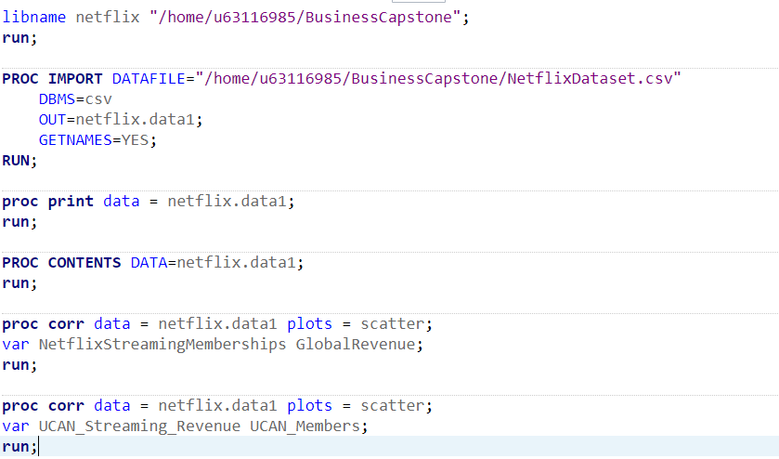

Appendix 2
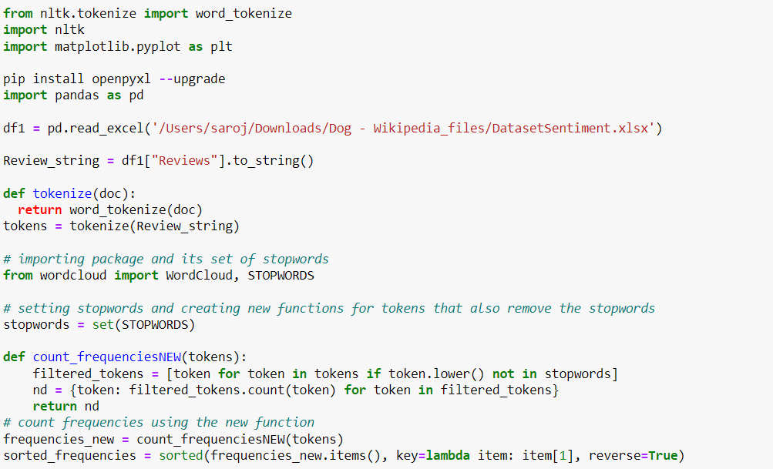
Appendix 3
